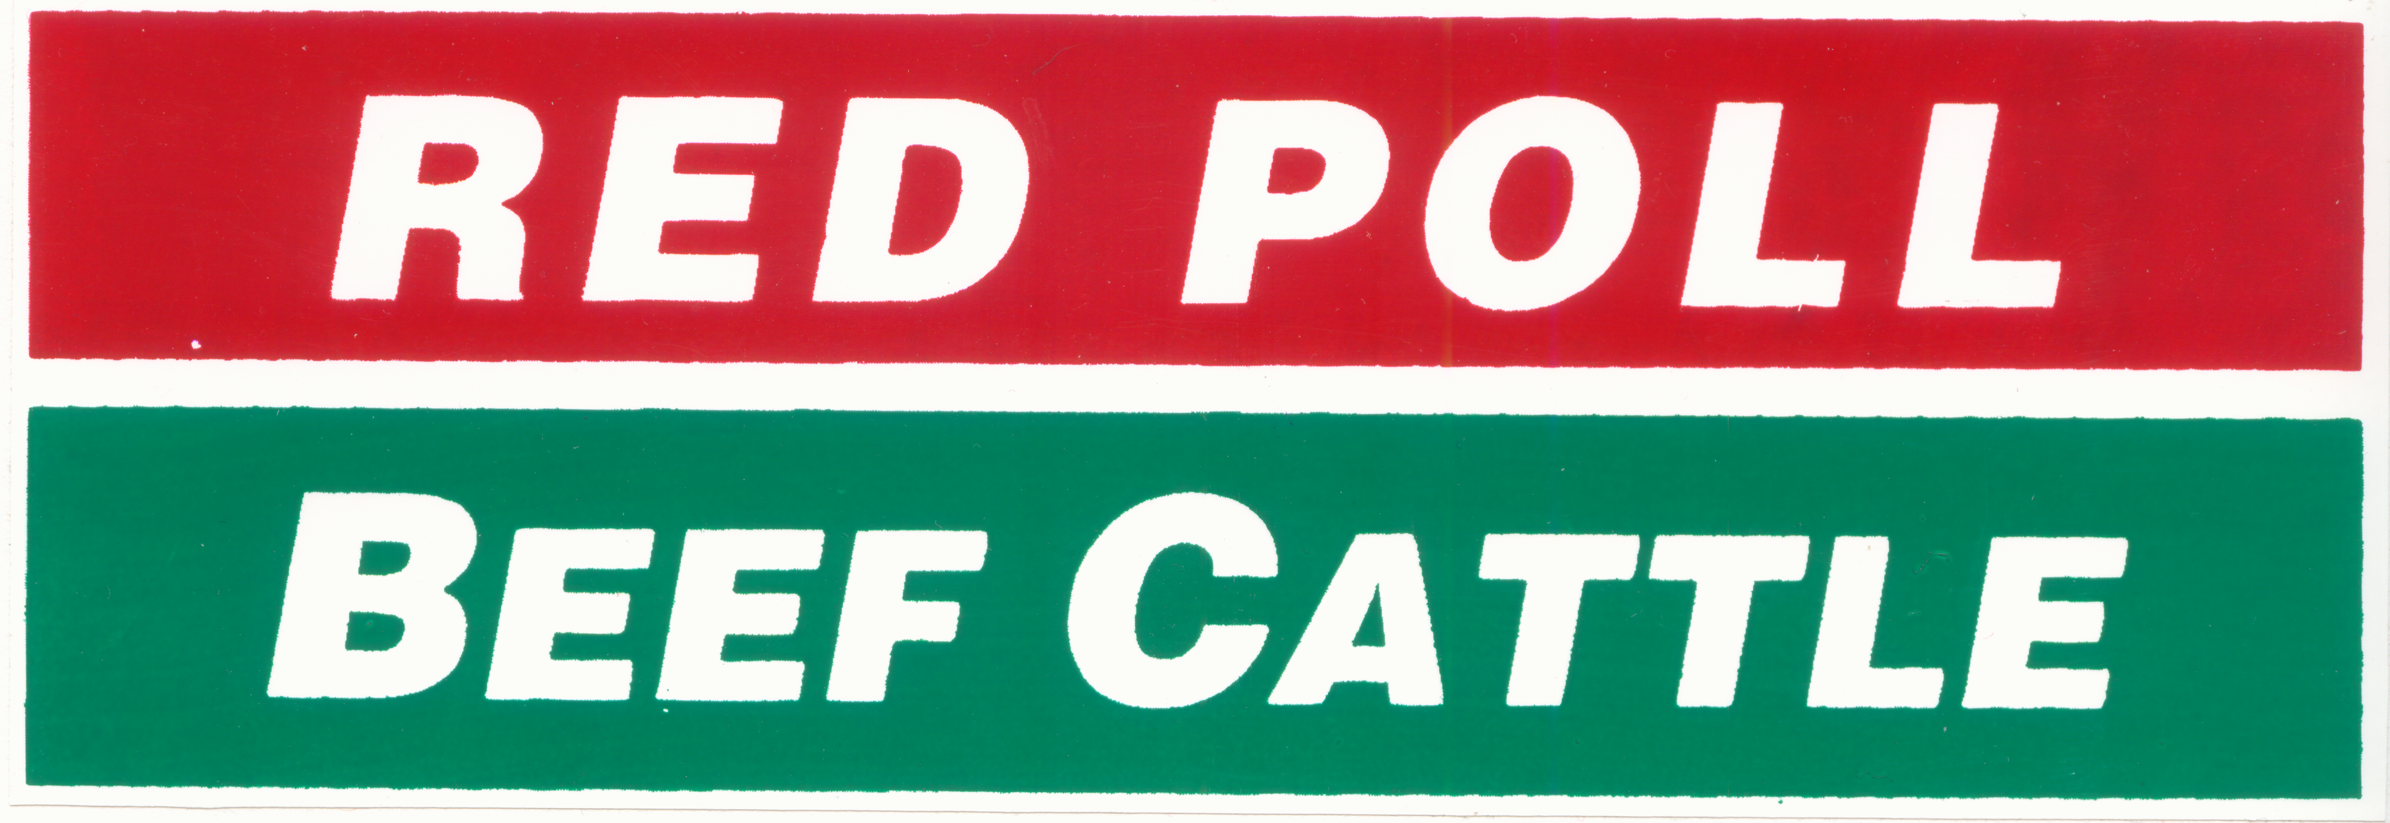
Australian Red Poll
Cattle Breeders Inc.
ABN: 57 926 822 056

AUSTRALIAN RED POLL CATTLE BREEDERS INC YOUTH AWARDS 2024

The Australian Red Poll Cattle Breeders Inc. will offer a junior member of the ARPCBI the opportunity to attend the South Australian Junior Heifer Expo. The winner will be awarded a scholarship to the South Australian Junior Heifer Expo held in Adelaide, usually in July.

This event is widely regarded as the premier youth programme in Australia and regularly attracts entrants from New Zealand.

Dedicated to the promotion and education of the beef industry, the SA Junior Heifer Expo focuses on all aspects of the beef industry and “life skills” such as public speaking, time management and developing a network within the industry.

Senior competitors will have the opportunity to compete for the major prize of a travel scholarship to America.

The aim of these awards is to allow Red Poll junior members the opportunity to increase their understanding of the beef industry.

The winners of these awards will earn
- Fully paid Entry fees
- The use of a Red Poll to compete with
- A travel subsidy to assist towards travel expenses (The subsidy may cover all costs for the winner depending on their departure location)

All junior members of the ARPCBI are invited to compete for these awards in 2023. To compete for the junior scholarship you will need to be a junior member of the Red Poll, have your parent’s permission to travel to Adelaide and be over the age of 14 years. Junior memberships in the name of a school can submit one nomination per school.

To enter juniors are asked to make a submission to the ARPCBI with details of their involvement with Red Polls, the beef industry and their goals for the future. Juniors are encouraged to submit other details of their achievements such as newspaper clippings, photographs or awards.

Entries will be judged on the level of:
- Red Poll involvement
- Beef Industry involvement
- Goals of the entrant within the beef industry

Please include in your submission your contact details including a phone number.
Australian Red Poll Cattle Breeders Inc
Junior Awards
PO BOX U66, Charles Sturt University
Wagga Wagga NSW 2678
Entries close on the 10th March 2022
and should be addressed to:

Further details can be obtained from:
Executive Officer
Australian Red Poll Cattle Breeders Inc.
Phone: 02 6933 1214
Email: office@genetichub.com.au

CONDITIONS OF ENTRY
- The competition is limited to junior members of the Australian Red Poll Cattle Breeders Inc.
- The closing date of the competition will be the 10 March 2023 and no late entry applications will be accepted.
- Applicants for the South Australian trip will need parental permission to travel to Adelaide to compete at the South Australian Junior Heifer Expo. (If under 18 years of age)
- The decision of the judging panel will be final and no correspondence will be entered into. The judging panel may award one scholarship to the South Australian Junior Heifer Expo but reserves the right to not make one award.
- The ARPCBI may use any or all of the submitted entries for promotion purposes with the consent of the entrant.
- Entrants to be between 14 years and 23 years (inclusive) as of the 1st July 2022 to qualify for the South Australian awards.
- The ARPCBI will subsidize travel costs to South Australia however the winner may be required to contribute some travel expenses.
- Personal spending money will be the contestant’s own responsibility.

Please detach and send in with your entry

NAME…………………………………………………………….

ADDRESS………………………………………………………..

JUNIOR MEMBER CODE…………….PHONE:……………………….

I agree to abide by the conditions of entry of the competition and accept the decisions of the judging panel.

Signed……………………………………………..Date…………………..

I have the permission of my parent/guardian to attend an interstate event. I understand that the ARPCBI. will subsidize my travel costs but I may be required to contribute to the travel expenses involved.

Signed…………………………………………………..Date…………………..

REMEMBER ENTRIES CLOSE 10th March 2023.

